# Module 1(fundamental)

* What is SDLC?

- SDLC is structure which is applied on developed software process to devide several parts into requirement, planning, documentation, testing , implementation, deployment, and ongoing maintenance .

* What is software testing?

- Software testing is process which is use to identifying the correctness completeness and quality of developed computer software.

* What is agile methodology?

- Agile SDLC model is a combination of iterative and incremental process models with the focus on process adaptability and customer satisfaction by rapid delivery of working software product.

* What is SRS? (software requirement specification)

- A software requirements specification (SRS) is complete description of the behavior of the system to be developed.

* What is oops?

- Object oriented programming system: black box testing functional testing.

Write basic concept of oops?

1. Class
2. Object
3. Encapsulation
4. Inheritance
5. Polymorphism
6. Abstraction

* What is object?

- object: instances of class

: to create a memory of a class

: to access the whole properties of class expect private

Sy:

Class name object name = new class name( );

* What is class?

- class: is an collection of data member (variable) and member function (process method) with its objectives

SY:

Class name

{

Data member

Member function

* What is encapsulation?

- encapsulation: data hiding: wrapping up of data into single unit private your data member function

* What is inheritance?

- inheritance: properties of parents class extend into child

: main purpose is reusability, extedsiblity

: there are mainly 5 type

1 single

2 Multilevel

3 Hierarchical

4 Multiple : java does not support

1. Hybrid : java does not support

* What is polymorphism

polymorphism : ability to take one name having different forms

: many forms or multiple forms

1 compile time (method overloading)

2 run time (method overloading)

* Write SDLC phases with basic introduction

1. Requirement

- features

- usage scenarios

- requirement will change !

- the final system is delivered

- plan for change

- functional or non functional

Three types of problem can arise

1 Lack of clarity : it is hard to write documents that are bith preciseand easy to read

2 requirement confusion : functional and non functional requirement tend to be intertwined

3 requirement amalgamation : several different requirements may be expressed together

Types of requirement

1 functional requirement : describe system service or functions

2 non functional requirement : are constraints on the system or the developments

1. Analysis phase

- this phase defines the problem that the owner is trying to solve

- the deliverable result at the end of this phase is a requirement document

- this analysis represent th “what” phase

1. Design phase

- design architecture document

- implementation phase

- critical priority analysis

- performance analysis

- test plan

1. Implementation phase

- in the implementation

phase the team builds the components either from scratch or by composition

1. Testing phase

- simply stated, quality is a very important. Many companies have not learnt that quality is more important and delivere more claimed product functionality but at lower quality

1. Maintenance

- software maintenance is one of the activites in software engineering, and the process of enhancing and optimizing deployed software (software release) as well as fixing defects.

* Explain the phases of waterfall model?

- the classic software lifecycle n the software development as a step by step “waterfall’ between the various development phases.

* Write the phases of spiral model?

1 planning : determination of objectives, alternatives and constraints

2 risk analysis : analysis of alternatives identification resolution of risk

3 engineer : development of the “next level” product.

4 customer evaluation : assessment of engineering

* Write agile model manifesto principles?

1 individual interaction

2 working software

3 customer collobration

4 responding to change

* Explain working methodology of agile model and also write pons and cons

- agile SDLC is combination of iterative and incremental process models with the focus on process adaptability and customer satisfaction by rapid delivery of working software product.

* Pons

- is a very realistic approach to software development

- promotes team work and cross training ?

- functionality can be developed rapidly and demonstrated

- Resources requirement are minimum

- suitable for fixed or changing requirements

- little or no planning required, easy to manage gives flexibility to developers

Cons

- not suitable for handling complex depencies

- more risk of sustainability, maintainability and extensibility.

- An overall plan, an agile leader and agile PM practice is must without which is will not work

- depends heavily on customer interaction, so if customer is not clear, team can be driven in wrong direction.

* Draw usecase of online book shopping

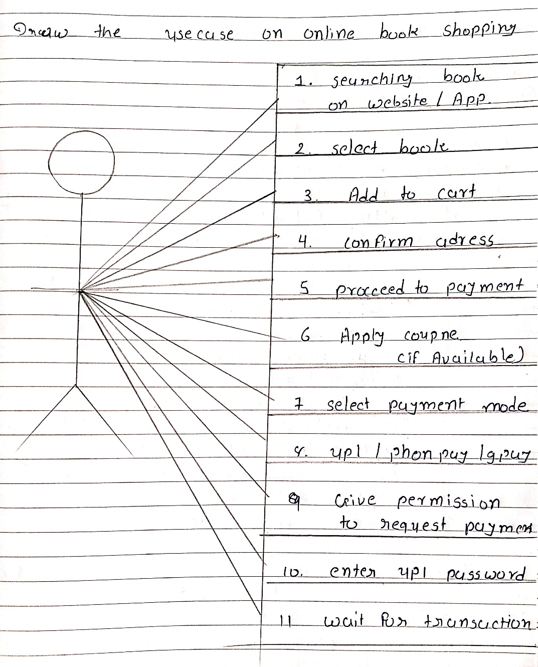

* Draw usecase of online shopping product using paymwnt getway

Draw usecase of online shopping by COD

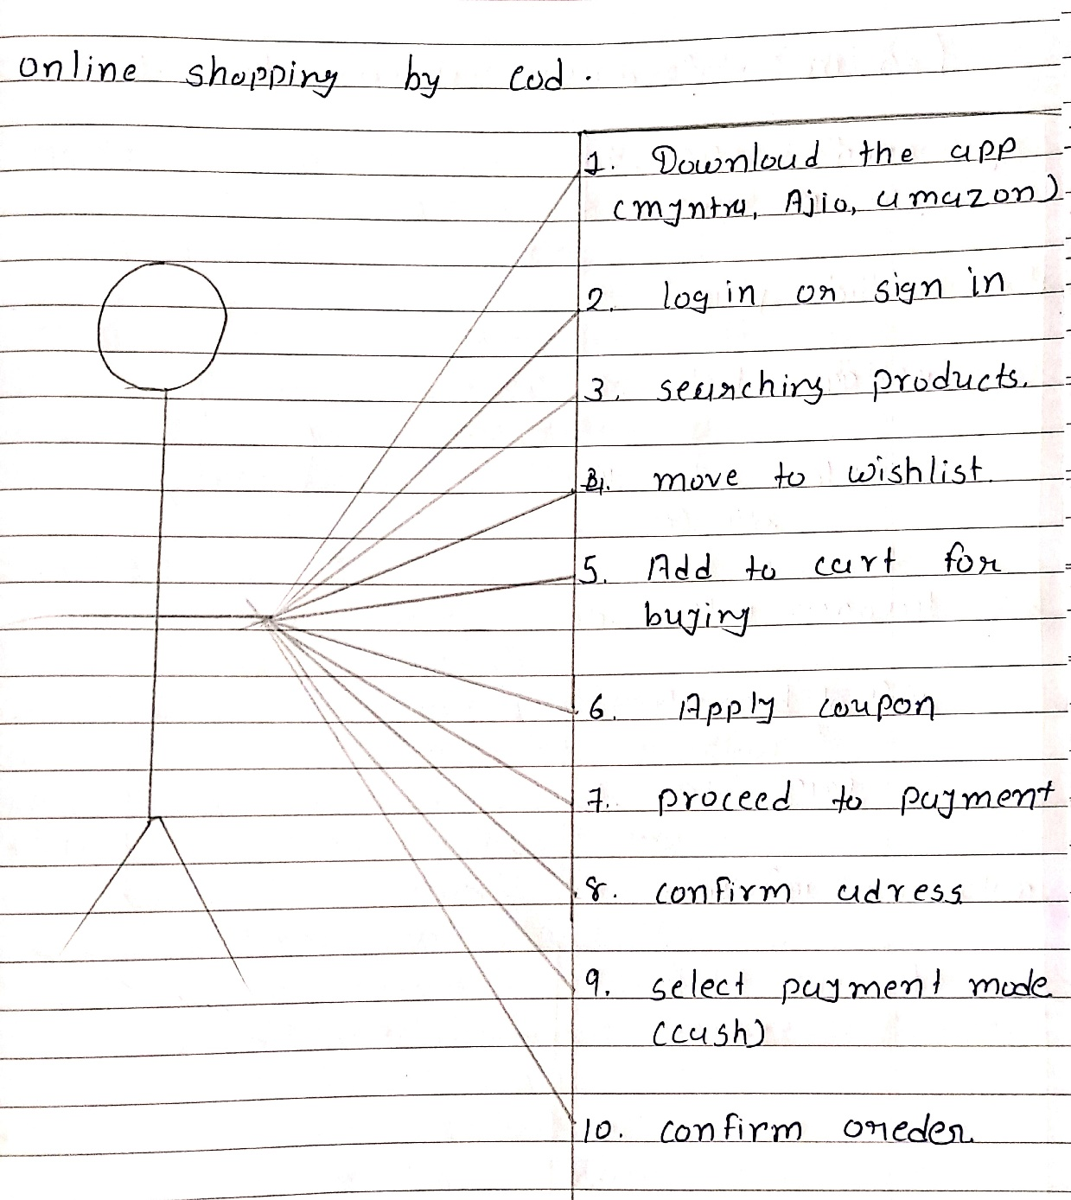

Draw usecase of light bill paying process online

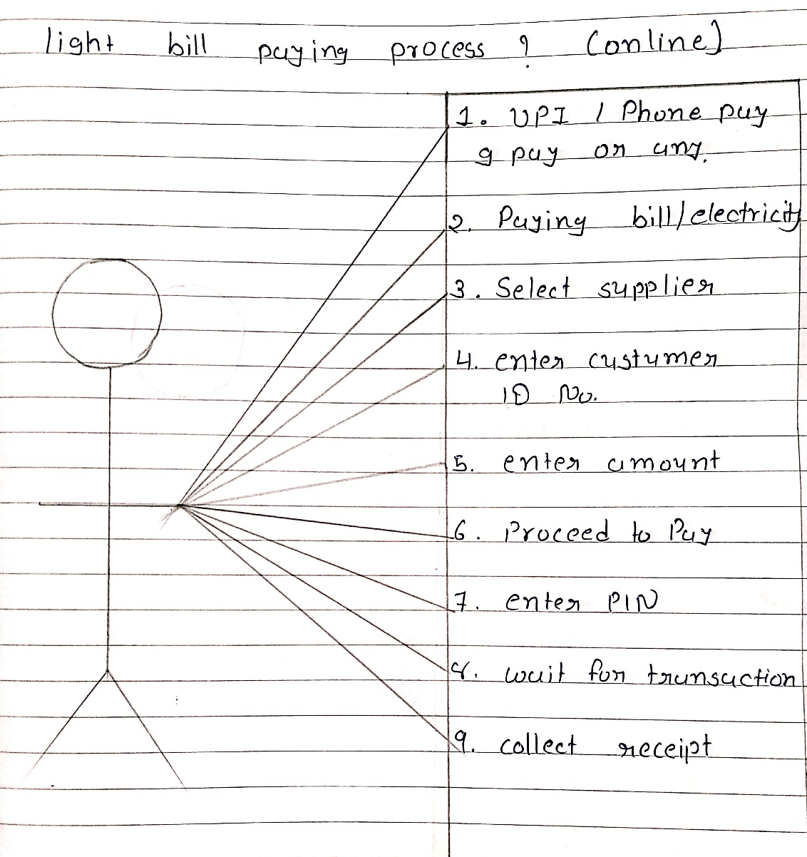

Draw usecase on online shopping product using payment gateway

